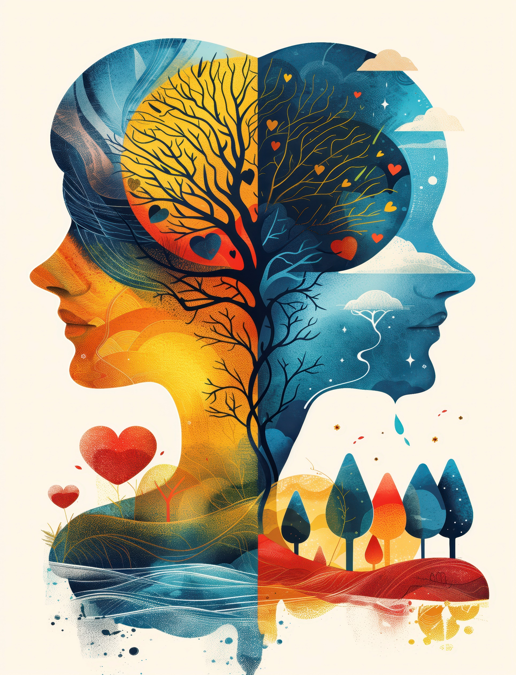

Debates in Psychology
Student no – 39733

Introduction
Since it is related to some of the more basic philosophical problems psychology has grown up as a scientific ground. And the questions of where these things come from, why they exist and what role they play in our lives. Arguments of nature against nurture, free will versus determinism, and holism as opposed to reductionism… Both parties have disparate but interrelated issues. The disagreements are whether life (to speak generically) is more a matter of their biology or their environment, and in the case of people, if we act consciously and voluntarily to satisfy our aims (as they filled me with it, so let them quench it), or have no choice as causal forces propel us into whatever direction; whether mental phenomena should be explained as whole cloth things, such as consciousness generally, or the result sen- sory things made simpler “building blocks” without any prior narrative at all. Either way, these arguments constitute the building blocks for numerous psychological theories and treatments.

The reason for examining both of these exchanges is to illustrate how divergent stances on human nature result in different explanations of behavior, research programs, and applied psychology. Although these are often treated as separate questions, these debates intersect in important ways. For instance, biological accounts usually coincide with deterministic and reductionist perspective. Environmental and humanistic points of view are more in accordance with free will, holistic views. Setting these controversies aside, the present report is intended to illustrate how they interrelate – complementing, conflicting and informing one another in moulding modern psychological thought.

The main point in this article is that the polar extremes of these debates are inadequate, by themselves, to account for the richness and complexity of human behavior. HANDLER Instead, there is greater value to psychology taking an integrative interactionist perspective that acknowledges the interactive effects of biology and environment, retains causality in explanations while also allowing a particularly human meaning of agency, and blends reductionistic accuracy with holistic comprehension. They also offer a more nuanced and pragmatic stance toward research or applied psychology that surpasses simple either-or positions.

This essay will contain mainly criticisms on the Nature versus Nurture issue, along with Free Will versus Determinism and Holism V Reductionism. Readers will consider evidence, pros and cons, real-life cases, and practical applications for contemporary mental health practice. The discussion will be followed by a cross-debate comparison concerning: philosophical background, procedural implications and possibilities in (clinical) psychology, education or neuroscience. Lastly, the conclusion will provide an overview on the key findings and reiterate the case for a holistic understanding of human behavior.

